The University Of Azad Jammu & Kashmir

Student Name: Qurat Ul Ain Fatima
Roll No: 2024-SE-05
Course Title: Software construction & Development
Course Code: SE-3101
Course Instructor: Engr. Dr. Asma Javaid
DEPARTMENT OF SOFTWARE ENGINEERING

LAB # 01
This lab illustrates UML Use Case Diagrams. The first task illustrates an Online Ticket Reservation System, while the second represents a Credit Card Processing System. These tasks show how different users interact with a system to perform specific tasks.

1. Online Ticket Reservation System (LAB 1 TASK 1)
Objective:
The purpose of this task is to explain the main functions of an Online Ticket Reservation System and how a customer interacts with the system to reserve tickets.
Explanation:
- Customer: The customer is the main actor who interacts with the online ticket reservation system to book, manage, and access tickets.
- Register / Login: The customer creates an account or logs in to an existing account to access the system.
- Search Ticket: The customer searches for available tickets by entering the required information, such as the destination, date, or type of ticket.
- Select Ticket: After searching, the customer selects a suitable ticket from the available options.
- Enter Passenger Details: The customer enters the necessary passenger information, such as name and other required details.
- Make Payment: The customer pays for the selected ticket through the payment gateway. The payment gateway is an external service that processes the payment.
- Confirm Booking: After successful payment, the system confirms the reservation and records the booking details.
- Cancel Booking: If necessary, the customer can cancel an existing reservation, subject to the system's cancellation rules.
- View / Download Ticket: After booking confirmation, the customer can view or download the ticket for future use.
Role of the Payment Gateway:
The payment gateway communicates with the reservation system to process the customer's payment and provide the payment result.
Conclusion:
This UML use case diagram shows the main activities involved in online ticket reservation, from registration and ticket selection to payment, booking confirmation, cancellation, and ticket downloading.
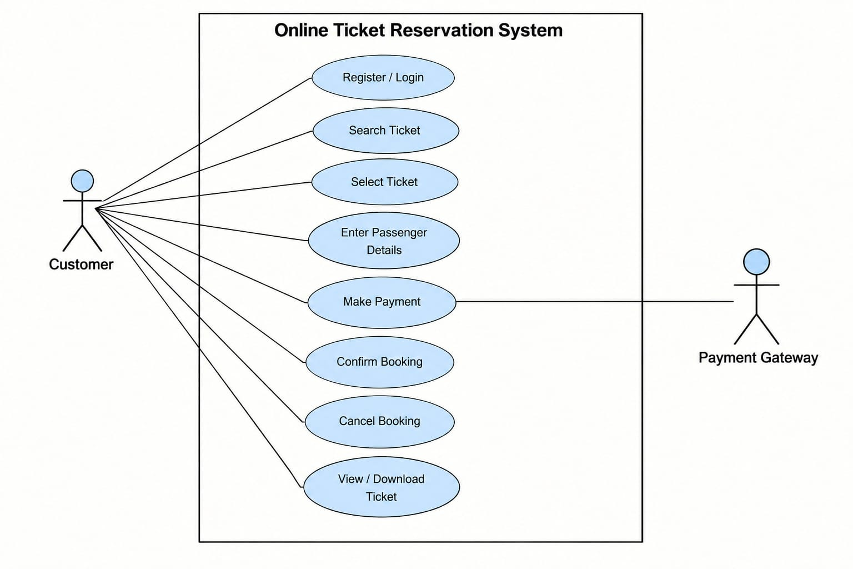

2. Credit Card Processing System (LAB 1 TASK 2)
Objective:
The purpose of this task is to explain how a customer, vendor, and credit card machine interact with a Credit Card Processing System to complete a purchase and generate a receipt.
Explanation:
- Customer: The customer selects an item, pays using a credit card, and completes the transaction.
- Vendor: The vendor provides the items or services to the customer and participates in the payment process.
- Select Item: The customer selects the item they want to purchase.
- Generate Bill: The system generates a bill containing the details of the selected item and the amount to be paid.
- Swipe Card: The customer uses a credit card through the credit card machine or card reader to provide payment information.
- Process Transaction: The system processes the payment transaction using the card information and the relevant payment services. The transaction result determines whether the payment is successful.
- Print Receipt / Balance Statement: After processing the transaction, the system produces a receipt or balance statement containing the relevant transaction details.
- Sign Receipt: The customer signs the receipt when a signature is required.
- Return Signed Receipt: The customer returns the signed receipt to the vendor for record-keeping and transaction verification.
- Credit Card Machine / Card Reader: This external device reads the credit card information and communicates with the processing system to support payment processing.
Role of the Vendor:
The vendor manages the sale, provides the selected item or service, and receives the payment confirmation and relevant transaction documentation.
Conclusion:
This UML use case diagram illustrates the main activities of a credit card payment process, including item selection, bill generation, card reading, transaction processing, receipt printing, and receipt signing.
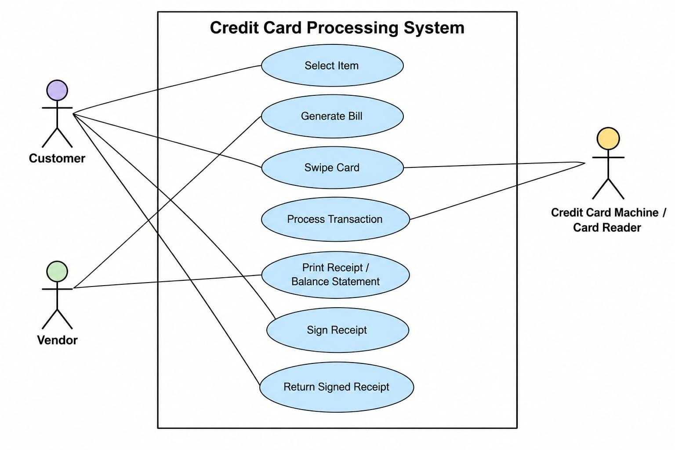

3. Main Difference Between the Two Diagrams
Feature | Online Ticket Reservation System | Credit Card Processing System
Main purpose | To reserve and manage tickets online | To process credit card payments
Main actor | Customer | Customer and Vendor
External system/device | Payment Gateway | Credit Card Machine / Card Reader
Main activities | Search, select, book, cancel, and download tickets | Select items, generate bills, process payments, and print receipts
Final outcome | A confirmed ticket reservation | A processed payment and transaction receipt
Overall conclusion: Both tasks are UML use case diagrams that describe the functional requirements of their respective systems. They identify the actors, the system boundary, the use cases, and the relationships between actors and system functions.

